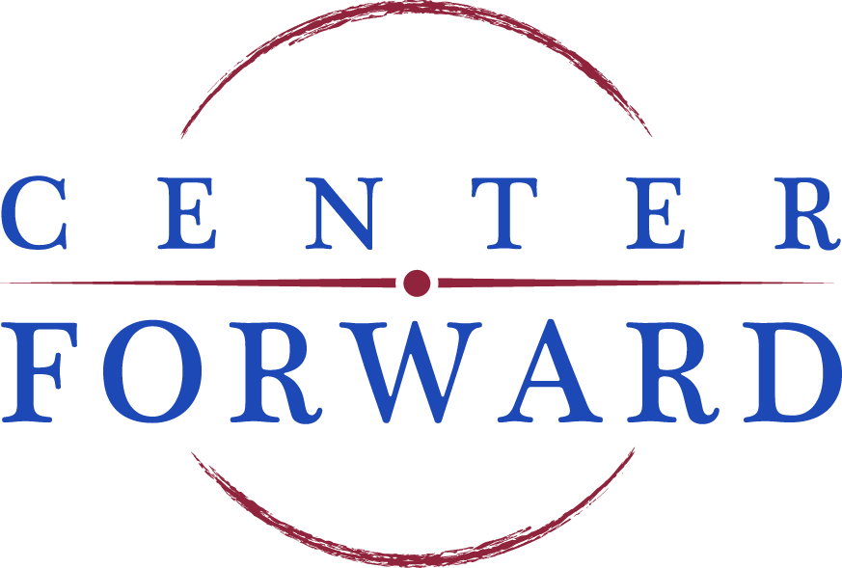

DIRECTOR OF PROGRAMMING

Center Forward is seeking a hard-charging, collaborative Director of Programming who is inspired by our mission to give centrist allies the information they need to craft common sense solutions, and provide those allies the support they need to turn those ideas into results.

The primary role of the Director of Programming in the organization is to develop, coordinate, and execute a robust agenda of programming to achieve organizational goals. In doing so, the Director of Programming will:
- Lead the creation and execution of Center Forward’s premier events including regular programming in Washington, D.C., the annual Domestic Issues Conference and the annual International Issues conference, in addition to other travel conferences
- Build relationships on The Hill and throughout D.C., including identifying potential third-party partners, project opportunities, and stakeholders
- Establish and maintain relationships with chiefs of staff, committee staff, and Members of Congress, including identification of new Members and their staff coming in on the 2 year cycle
- Enable seamless participation for Center Forward key stakeholders and partners by coordinating requests and engagements with policy influencers
- Track issues for and regularly engage with key stakeholders through a variety of mediums to further connect to the work and mission of Center Forward
- Setup and maintain detailed files and records of all work to track goals, metrics, and definitions of success
- Build broad brand identification and awareness within the business and political communities in and out of Washington, D.C.
- Perform various other duties that may be assigned from time to time based on the needs of the organization

Are you someone who:
- Is a passionate and creative problem solver?
- Is a collaborator and team player?
- Is an excellent communicator - written and verbal?
- Is detail-oriented while remaining flexible?
- Is excited by a fast-paced work environment?
- Is able to persevere through difficult situations with composure and humor?
- Is eager to learn and grow?

If so, we want to talk to you about Center Forward’s Director of Programming role. Additional qualifications include:
- Strong communication and interpersonal skills
- Expertise in GSuite, including Docs, Sheets, and Slides
- Proficiency in the Microsoft Office suite, including Word, PowerPoint, and Excel
- Knowledge of government, legislative, and executive processes is helpful, but not required

To apply, please submit a resume and 1-page cover letter as one document in PDF format. Applicants can submit application materials to jobs@center-forward.org with the subject line “Director of Programming.”

Compensation and Benefits:
Center Forward is an organization that believes work and life should be in balance. We offer transparency about pay ranges and competitive benefits.

The salary range for the Director of Programming position (salaried, exempt) is $70,000 - $80,000 USD.

Benefits at Center Forward include:
- Generous contribution (60% of monthly premium) to a co-pay healthcare and dental plan
- 50% match of employee’s 401k contribution (up to contribution maximum)
- Hybrid and flexible work schedules
- Unlimited PTO and liberal leave schedules
- Performance-based bonuses
- And other benefits, further details provided upon request

Organization Summary:

Center Forward brings together members of Congress, not-for profits, academic experts, trade associations, corporations and unions to find common ground. Our mission: to give centrist allies the information they need to craft common sense solutions, and provide those allies the support they need to turn those ideas into results.

In order to meet our challenges we need to put aside the partisan bickering that has gridlocked Washington and come together to find common sense solutions.

For more information, please visit www.center-forward.org.

Center Forward is an equal opportunity employer. Our jobs are open to all applications regardless of race, color, sex, gender identity, sexual orientation, age, religion, national origin, marital status, pregnancy, disability, military status, or any other basis prohibited by federal, state, or local law.

